MyDesign Portfolio
Element D Initial Template

Element D: Design Concept Generation, Analysis, and Selection

Design Idea Generation (D1)
Design Idea #1: 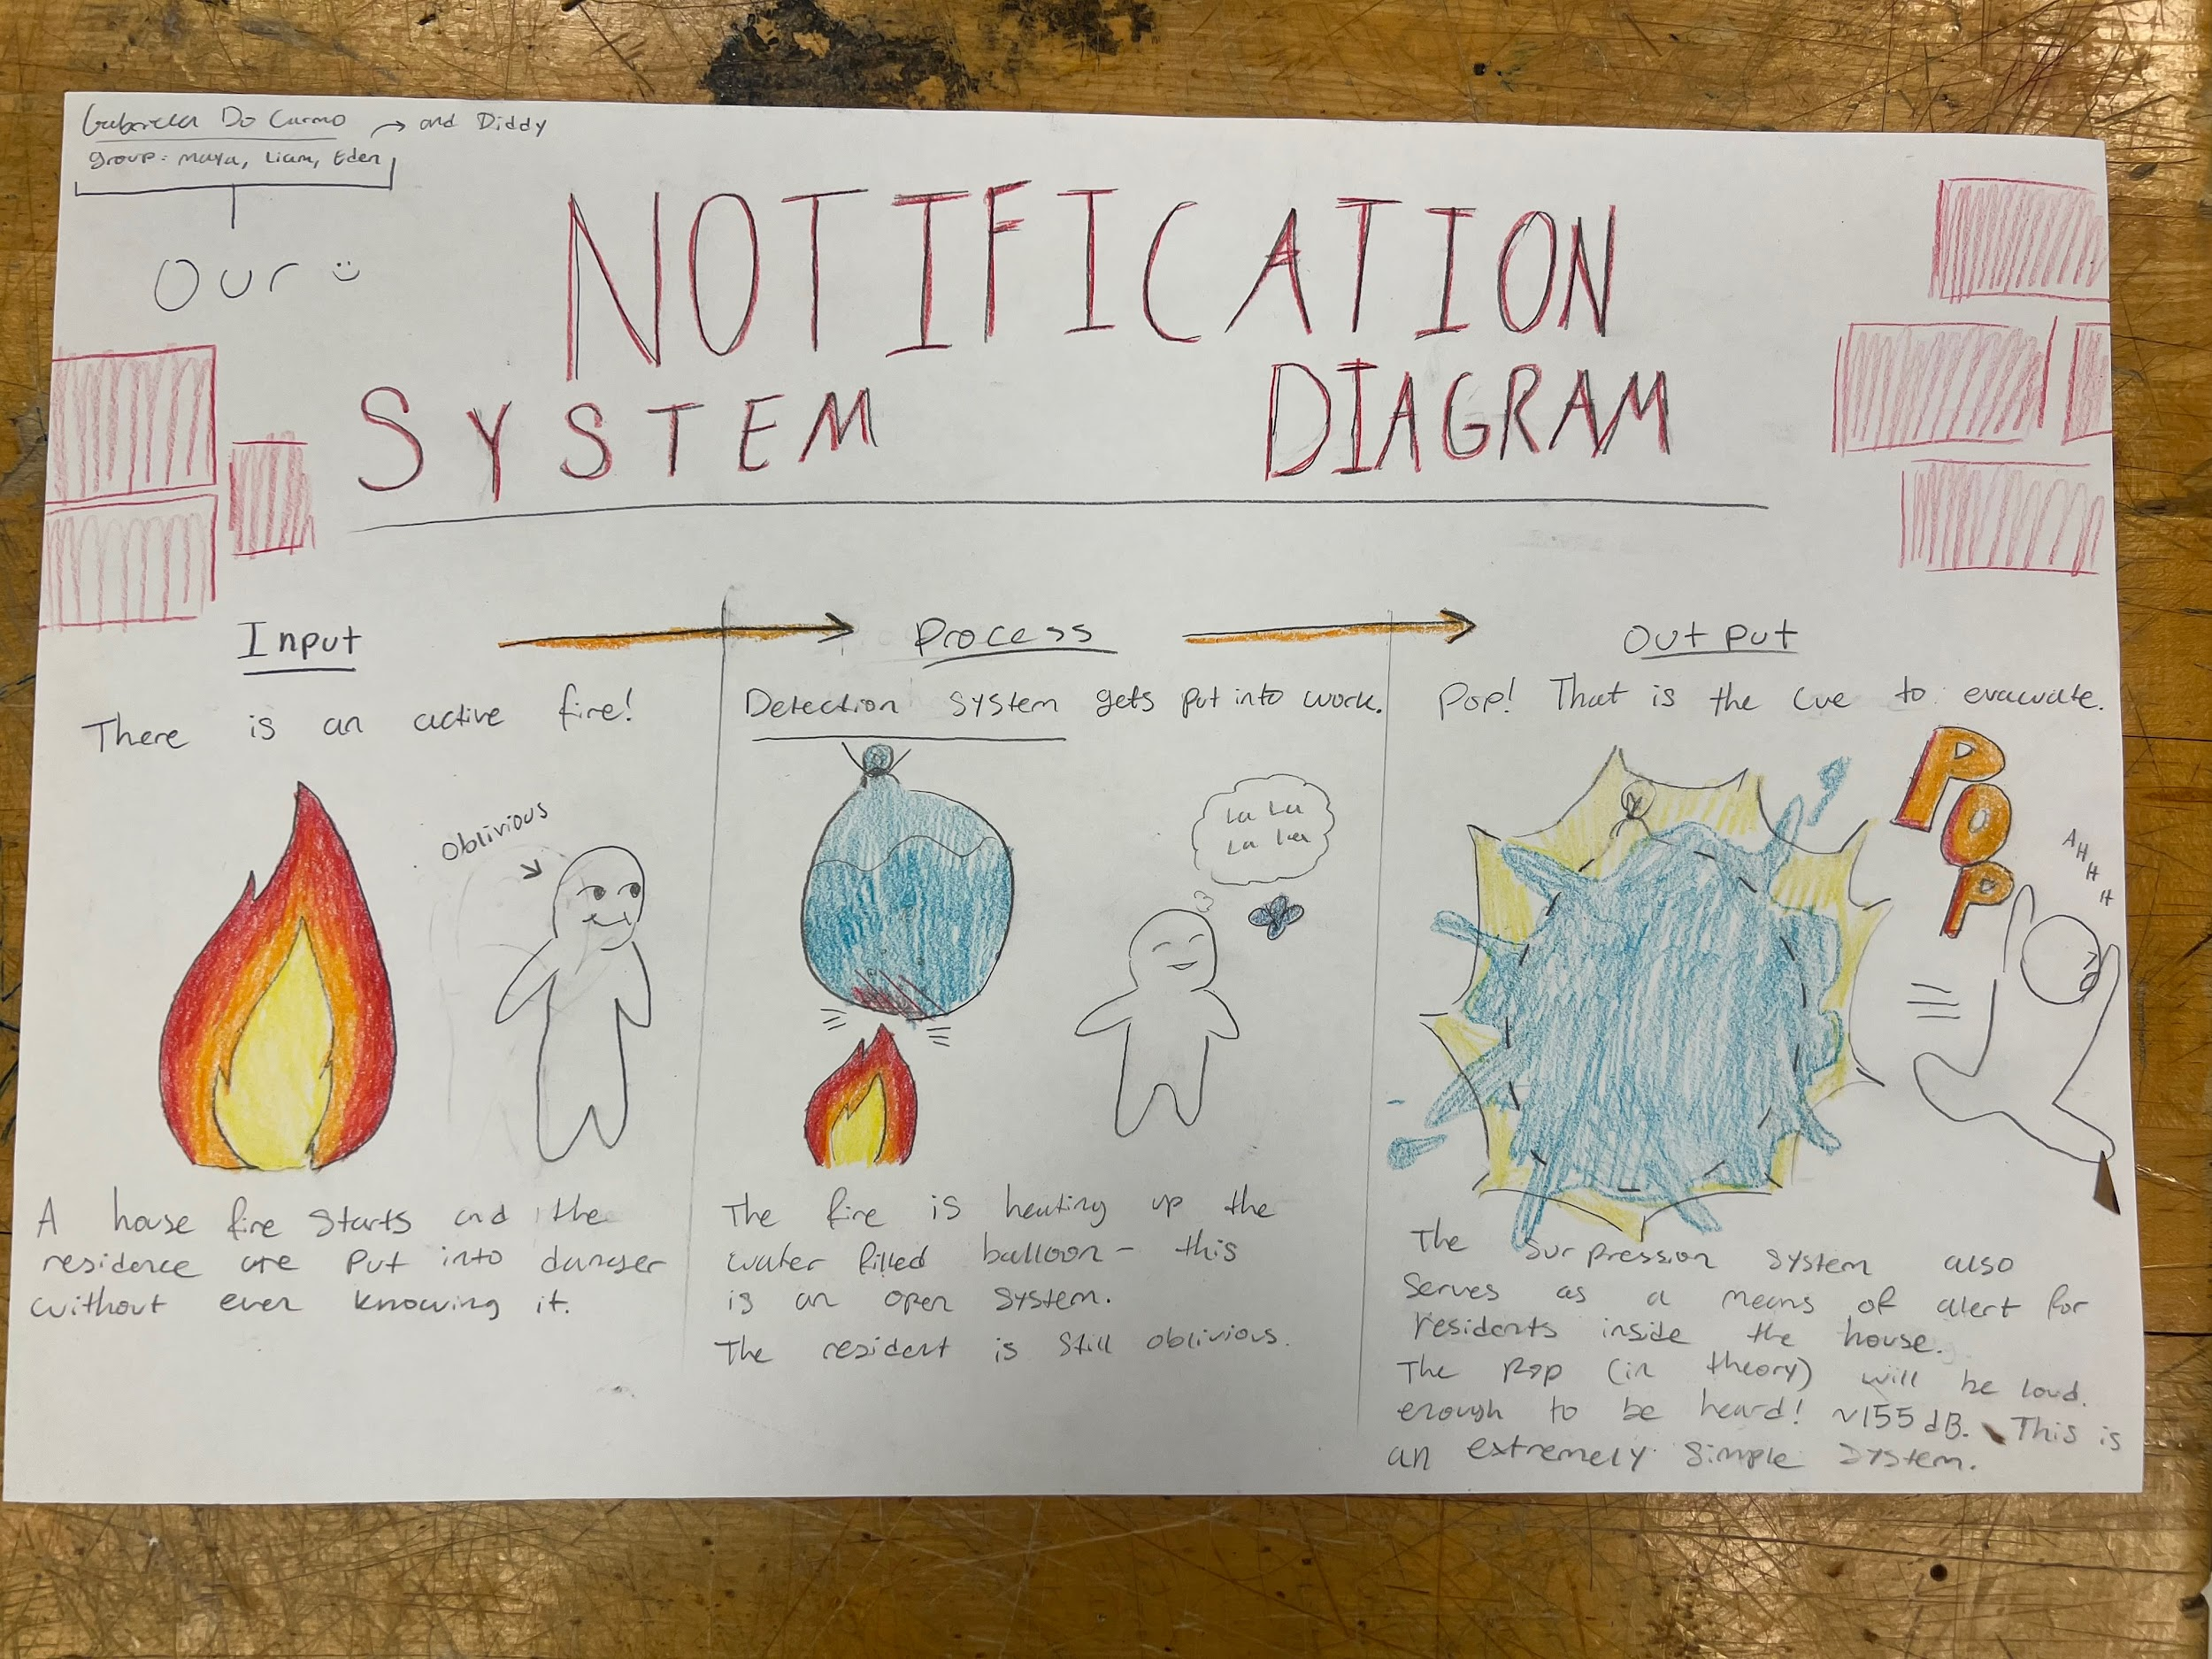

Date:
Description: The idea for the notification system was all about the balloon, as we know heat rises, if the balloon is big and thin enough, it would be very easy for the balloon to pop, hoping that as soon as it touches the balloon.
Drawing that includes distinguishing information such as scale, dimensions, and materials:
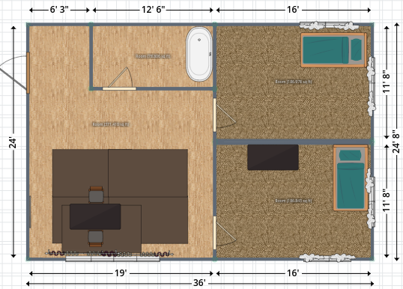

Design Idea #2: 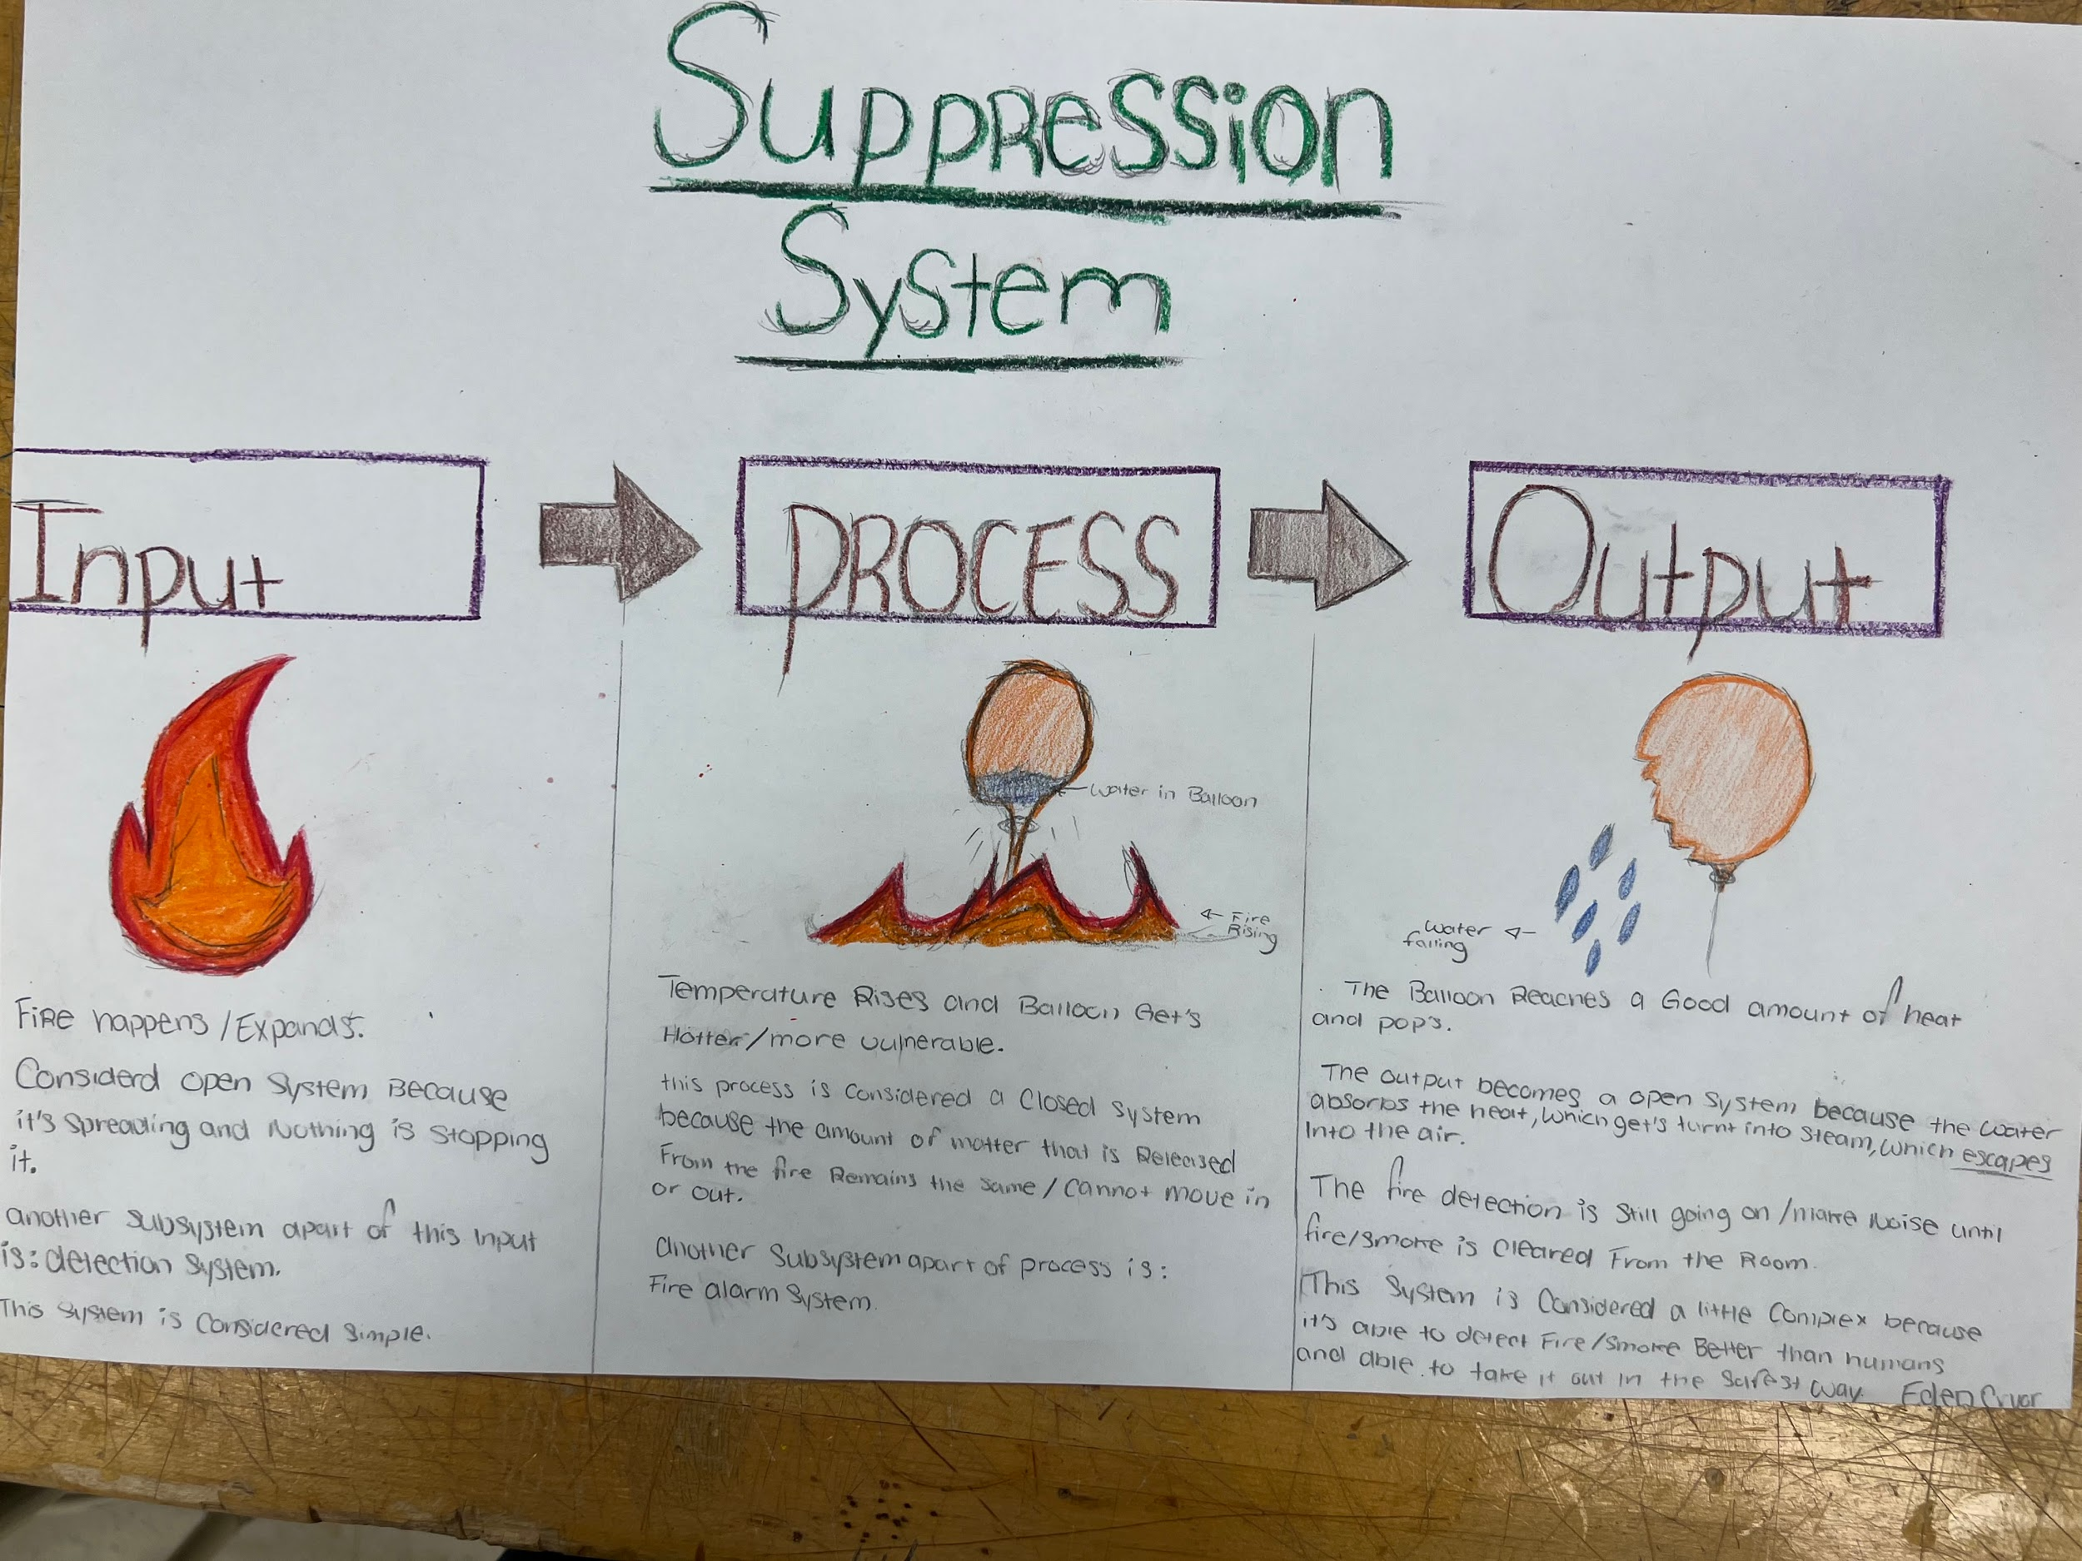
Date:
Description: All these systems distinguish the main goal/ idea, which mostly relies on the heat of the fire to activate everything. As soon as the fire hits the balloon, the water that was filled in will pop, decreasing the fire that started.
Drawing that includes distinguishing information such as scale, dimensions, and materials: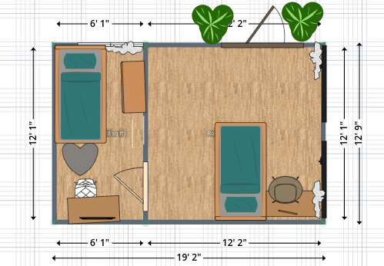

Design Idea #3 : 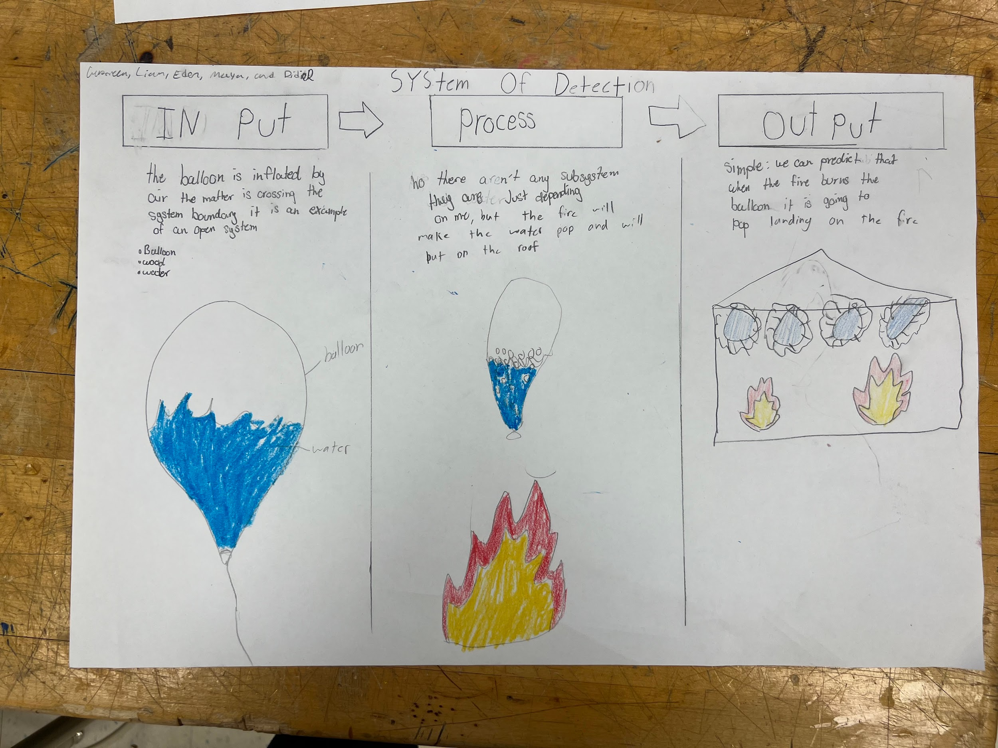
Date:
Description: When the heat rises due to the fire, the pressure on the balloon allows it to pop. That loud pop will alarm that person in the house.
Drawing that includes distinguishing information such as scale, dimensions, and materials:
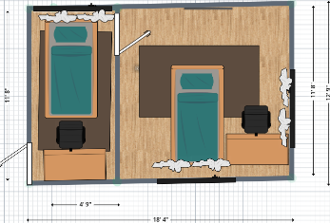

Design Idea Comparison and Selection (D1, D2)

 | weight | Option 1: Water balloon | Option 2:  Baking soda | Option 3:  Foam | Option 4: Water tank
Suppression system | 5 | 5 | 4 | 3 | 1
Detection system | 5 | 4 | 1 | 1 | 1
Notification system | 4 | 4 | 1 | 1 | 1
Furniture | 2 | 1 | 2 | 3 | 3
Materials | 4 | 2 | 1 | 2 | 3
score | 17 | 14 | 8 | 10 | 9

Our team chooses design 1 ( water balloon) to solve the community problem.

Design Blueprint (D4)
.
Design Blueprint #1 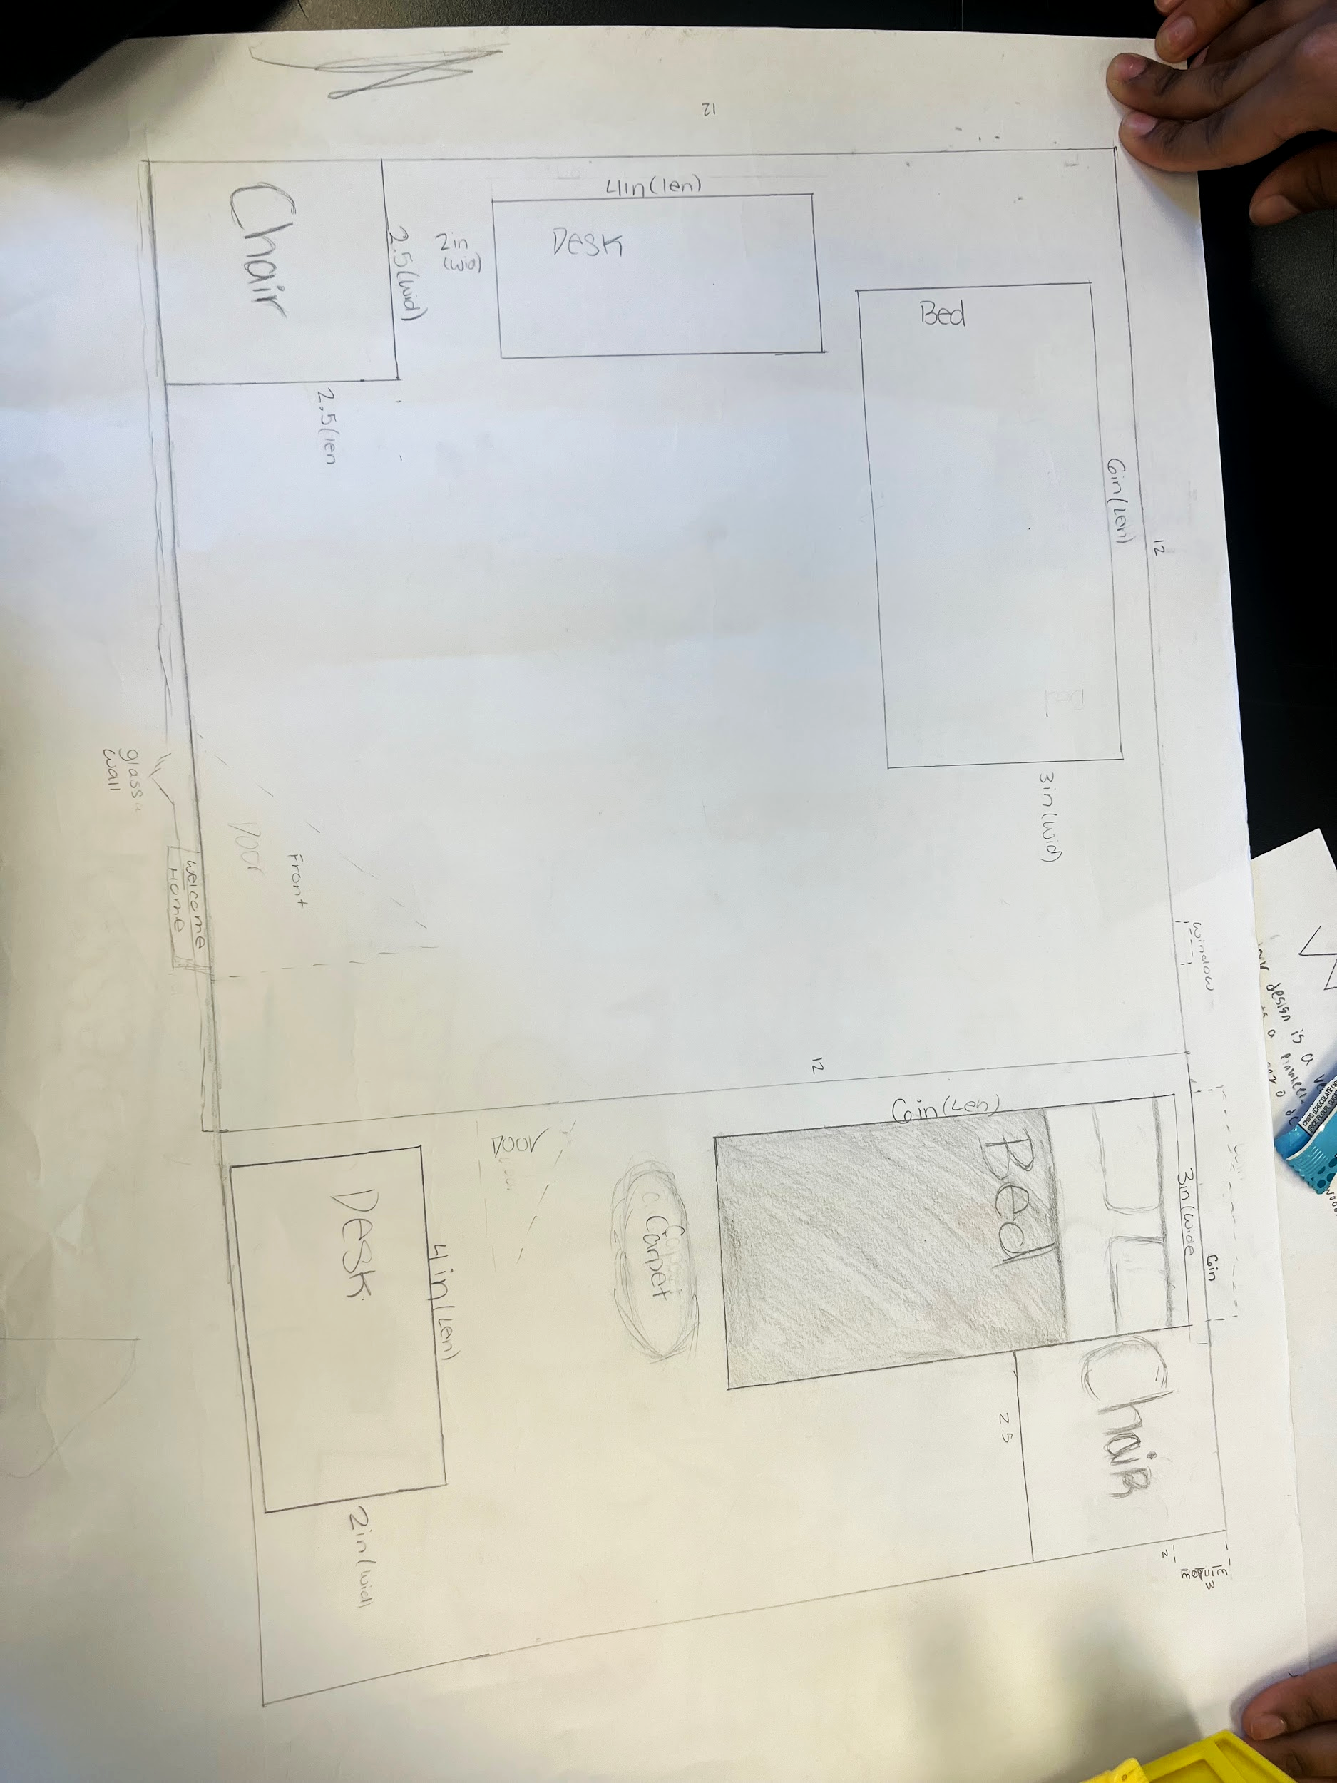
Date:
Manufacturing Methods:
Step 1: Make 3 rooms, which have 2 beds in each room
Step 2: Make 3 windows, 2 in one, 1 in the other
Step 3: Create a carpet
Supply List and Potential Costs:
Item | Cost each | # needed | Total
Cardboard | $0.27- 16.51 | 20 | $ 1.2- 74.07
Cardboard cutter | $32.99 | 1 | $32.99
Glue gun | $6.87 | 1 | $6.87
Total Cost | 40.13- 56.37 | 22 | $40.86-113.98

Iterations for the Solution:
The prototype did change along the way, we changed some of the materials, and where and how we wanted our system to work.

Design Blueprint #2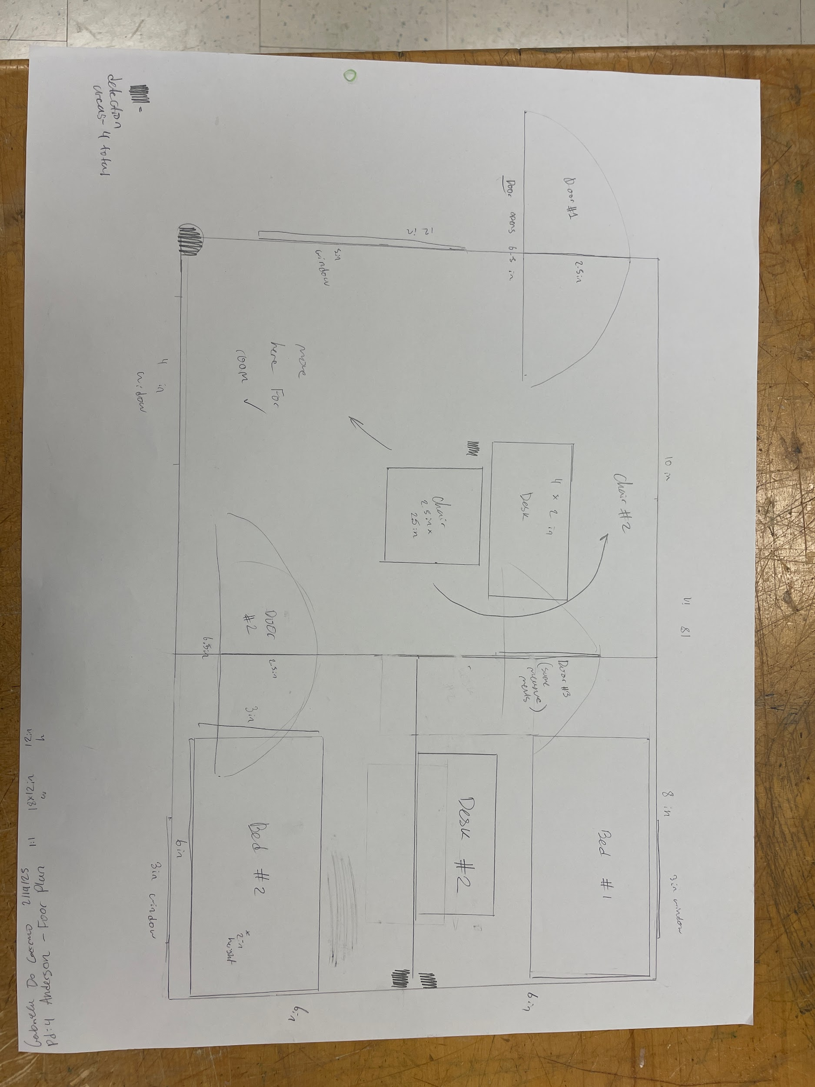:
Date:
Manufacturing Methods:
Step 1: 7 cardboards, to make 3 rooms
Step 2: Glue all cardboards together ( floor, 4 exterior walls, and 2 interior walls )
Step 3: Cut
Supply List and Potential Costs:
Item | Cost each | # needed | Total
Cardboard | $0.27- 16.51 | 20 | $ 1.2- 74.07
Scissors | $20.8 | 1 | $20.8
Thermocol Craft Razor Cutter Blade | $2.21 | 1 | $2.21
Total Cost | $23.8-39.52 | 211 | $ 24.21- 97.08

Rubric
Element D: Design Concept Generation, Analysis and Selection
 | 5 | 4 | 3 | 2 | 1 | 0
1. Process for Generating & Comparing Possible Solutions. The Process for Generating Possible Solutions _____________. | was comprehensive, iterative, and consistently defensible (viable design highly likely) | was thorough, iterative, and generally defensible (viable design likely) | was adequate, generally iterative and defensible (viable design is possible) | was partial or overly general and only somewhat iterative and/or defensible (raising issues with the design viability) | was incomplete or minimally iterative and/or defensible (raising issues with the design viability) | was not evident that there was an attempt
2.Design Solution Choice. The Design Solution chosen ____________. | was well-justified and demonstrated attention to all design requirements | was justified and demonstrated attention to most if not all design requirements | was explained with reference to at least some design requirements | was not sufficiently explained with reference to design requirements | lacked support related to design requirements | was not attempted or evidence not provided
3. Plan of Action. The plan of action _____________. | has considerable merit and would easily support repetition and testing for effectiveness by others | would support repetition and testing for effectiveness by others | might not clearly or fully support repetition and testing for effectiveness by others | has insufficient detail to allow for testing for replication of results | is lacking to the point that the design solution cannot be tested | cannot be executed or does not exist

